Creating HTTP Requests To Communicate With Mobile App

|  |  |
| --- | --- |
| **Team ID** | **PNT2022TMID50805** |
| **Project Name** | **Hazardous Area Monitoring for industrial Plant powered by IoT** |

Constructing HTTP for communicating with mobile application:



HTTP function:

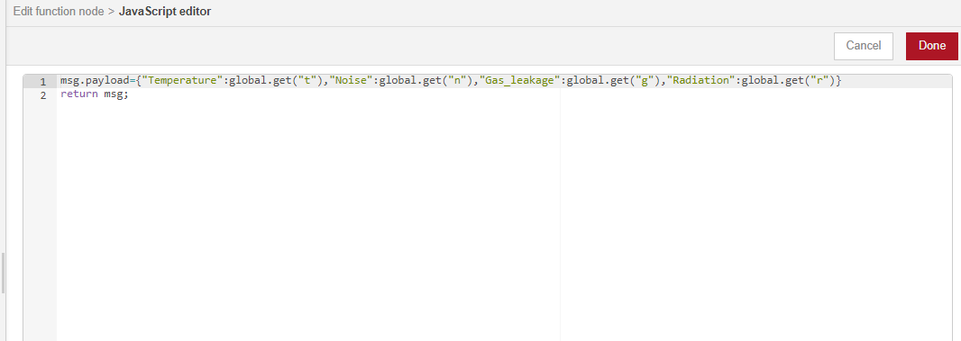

HTTP Message to be displayed:

